**Project Report**

Candidate name – Harshada Patil

Project Name – Shopping Cart

Project Guide – Rajiv Gupta

**User URL**

|  |  |
| --- | --- |
| **URL Exposed** | **Purpose** |
| /api/getAllProduct | To see all available product |
| /api/getOrder{order_id} | To search order by order_id |
| /api/getProduct{product_id} | To search product by id |
| /api/placeOrder | To place order |
| /api/ signup | To signup |
| /api/ login | To log in |

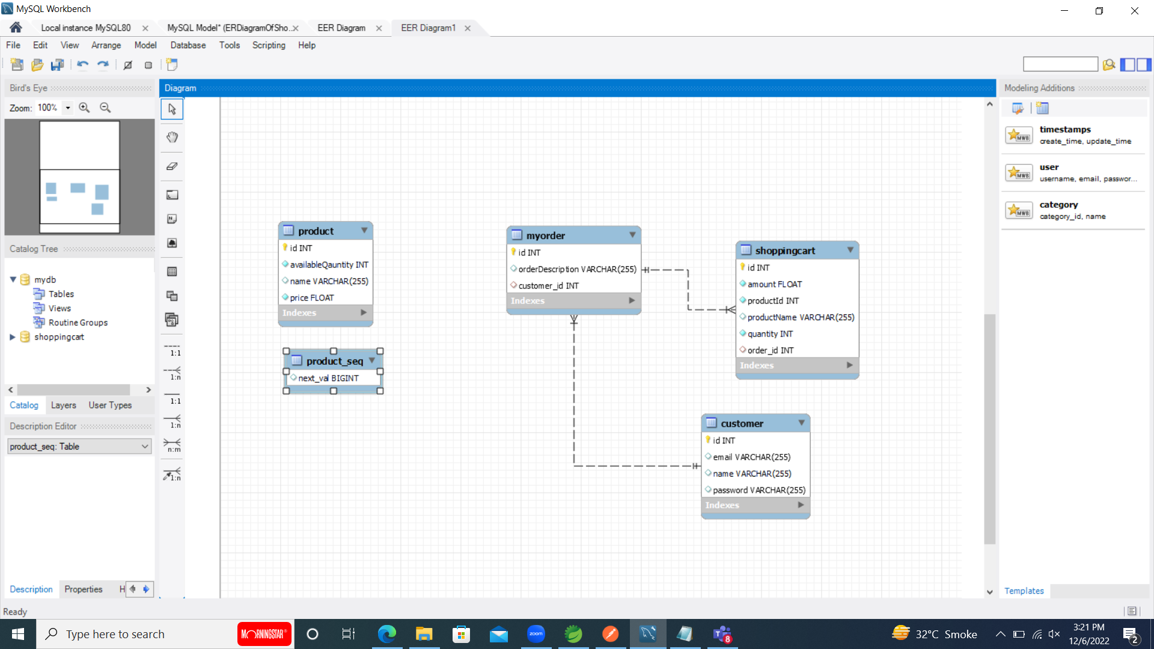

**ER Diagram**

***Pending things from version1.0***

*Error messages should display properly

*Exception handling should do properly